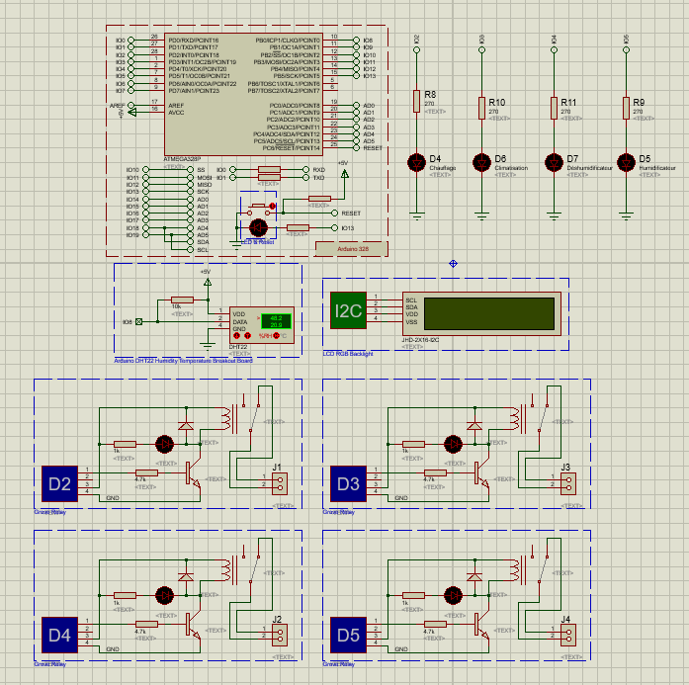

Capteur DHT22 I08

Ecran lcd I2C

Led chauffage I02

Led climatisation I03

Led Déshumidificateur I04

Led Humidificateur I05

Grove Relay D2

Grove Relay D3

Grove Relay D4

Grove Relay D5